**MID LAB**

**MUHAMMAD USMAN MALIK (SP21-SE-063)  
TAHIR AHMED KHAN (SP21-BSE-086)**

**SECTION: BSE 6B**

**Human Computer Interaction**

**20 NOV 2023**

**Instructions**

**System: MS Teams, tasks are to scheduling and attending a distinct location collaboration meeting**

Assignment Deliverables

You need to submit a report containing the following items:

♣**Small description** of the chosen system

♣ Chosen **features and the corresponding tasks designed.**

♣ Criteria, along with **sample of population**table

♣ **Contexts**along with sample of population table

♣ User’s **Feedback/Suggestion**s obtained through QUIS – Questionnaire of User Interface Satisfaction

♣ **Data Analysis** based on QUIS questionnaires

♣ **Recommendations** to improve the usability of the system

**Small description of the chosen system:**

Microsoft Teams is a versatile communication platform that facilitates workplace collaboration. It offers chat, video conferencing, file sharing, and integration with other Microsoft Office applications. Designed for both small teams and large enterprises, it streamlines workflows and enhances productivity, embodying a modern approach to professional connectivity and team management.

**Chosen features and the corresponding tasks designed:**

* **Scheduling Meetings:** Successfully organize a virtual team collaboration meeting, indicating a specific location.
* **Attending Meetings:** Effortlessly connect and engage in a virtual meeting, emphasizing collaboration while taking into account different locations.

**Criteria, along with sample of population table:**

* Age (18-25, 25-50, >50)
* Expertise in office 360 (Yes/No)
* Familiar with Internet (Yes/No)

|  |  |  |  |  |  |
| --- | --- | --- | --- | --- | --- |
| User ID | Age (18-25) | Age (25-50) | Age (> 50 | Expertise in office 360 | Familiar with Internet |
| 1 | 21 |  |  | X | X |
| 2 |  | 45 |  | X |  |
| 3 |  |  | 65 |  | X |
| 4 | 23 |  |  |  | X |
| 5 | 25 |  |  |  |  |
| 6 |  | 38 |  | X |  |
| 7 |  | 47 |  | X | X |
| 8 |  |  | 55 |  |  |
| 9 |  |  | 54 | X | X |
| 10 |  |  | 68 |  |  |

**Contexts along with sample of population table:**

* Network status (Stable, Unstable)
* Device used (Laptop, Mobile)
* Extraneous influences (Yes/No)

|  |  |  |  |  |  |  |
| --- | --- | --- | --- | --- | --- | --- |
| User ID | Network Status  (Unstable) | Device Used | | | Network Status  (Stable) | Extraneous influences |
|  | | Laptop | | Mobile |  | |
| 1 | X | X |  | | X | X |
| 2 | X |  | X | |  | X |
| 3 | X |  | X | | X |  |
| 4 |  |  | X | |  |  |
| 5 |  |  | X | | X |  |
| 6 |  |  | X | |  |  |
| 7 |  |  | X | |  | X |
| 8 | X | X |  | | X | X |
| 9 | X | X |  | | X |  |
| 10 | X | X |  | |  | X |

**User’s Feedback/Suggestions obtained through QUIS – Questionnaire of User Interface Satisfaction:**

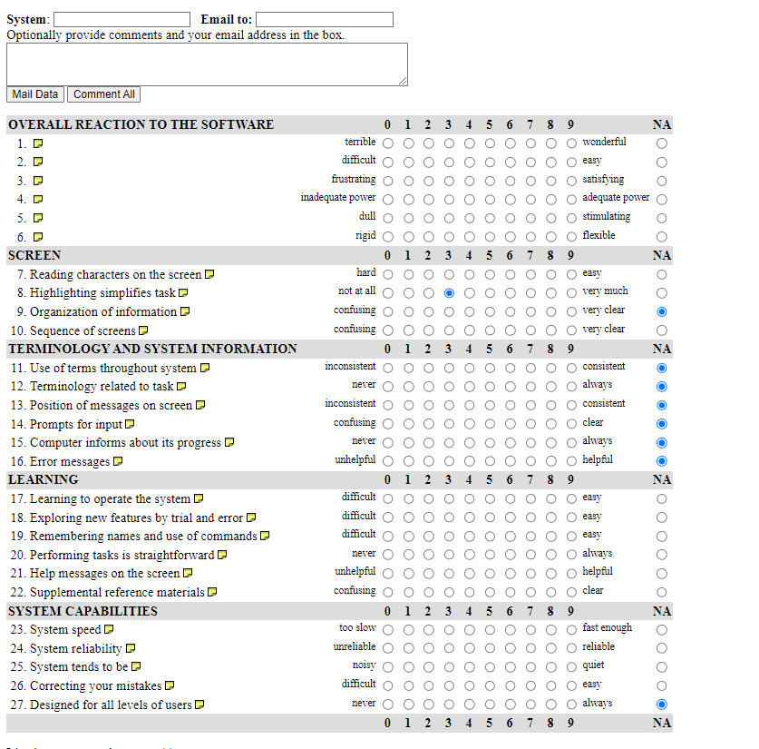

**Data Analysis based on QUIS questionnaire:**

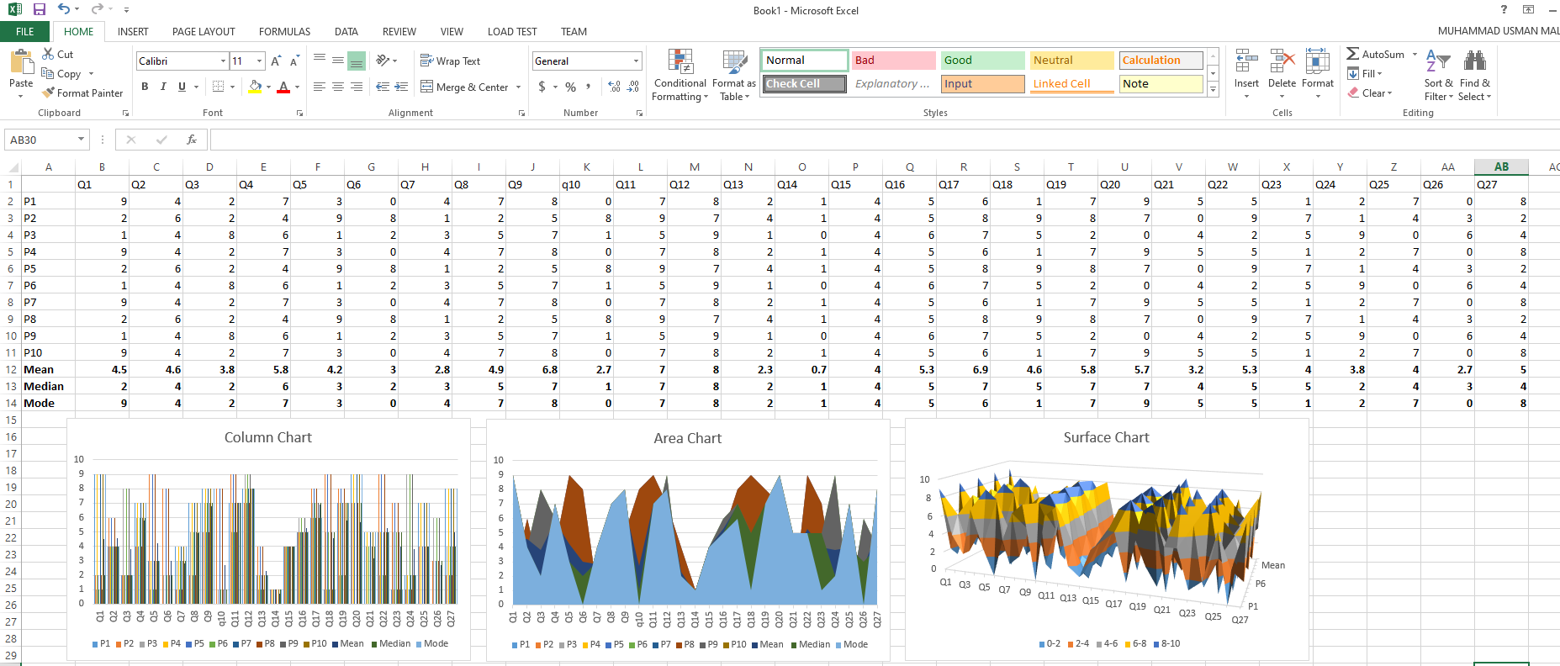

**Recommendations to improve the usability of the system:**

* **Optimize Location Specification Process:**
  + Introduce an intuitive interface for selecting meeting locations, seamlessly integrated with maps, enhancing user experience.
  + Incorporate a user-friendly autocomplete function for location names to minimize manual entry errors.
* **Enhance Virtual Collaboration Features:**
  + Integrate real-time language translation capabilities to facilitate seamless communication among participants in diverse locations.
  + Implement a virtual whiteboard and collaborative document editing tool within Microsoft Teams, fostering interactive collaboration during meetings.
* **Integrate User Feedback Mechanism:**
  + Establish a dedicated user feedback portal within the Microsoft Teams platform, enabling users to submit comments, suggestions, and issues directly.
  + Implement periodic pop-ups or notifications encouraging users to share feedback on their experiences with location-based collaboration.